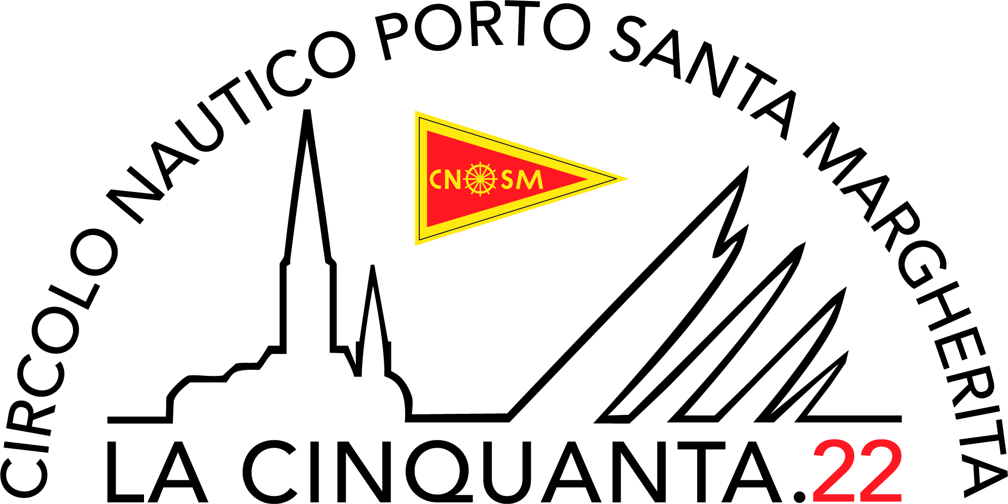

COMPLIANCE DECLARATION

Competitors must and sign the form given in all parts and deliver it to race office in Strada Sansonessa, 83 Caorle within 2 hour from the finish time, in one of the following ways:
- entering it in the mailbox at the CNSM Headquarter in Strada Sansonessa 83, Caorle
- by given to assistance rib at sea
- by email to info@cnsm.org
- by Whatsapp on +39.336.829581

To the Organising Authority of : LA CINQUANTA 2022

The competitor ………………………………………………….…………….as skipper of …………………………..………………………...…….

declare
to have completed the race complying all rules in the notice, sailing instruction and notices and I assume the responsibility of the trustiness of the inherent information regarding the time of rounding the check points and about the use of the engine to produce electricity to recharge the flat batteries.

Mark | DATE | HOUR | PREVIOUS BOAT | FOLLOWING BOAT
LIGNANO Buoy
GRADO Buoy
LIGNANO Bouy
CAORLE

Retire area
The retire happend close to ………………………………….………GPS point ……………………….……………………………

Cause ……………………………………………………………………………………………………………………………………………………..

Engine Use book
DATE | From hour | To time | Area

date…………………………. The Skipper…………………………………….………..

