3-5 maggio 2024

SAILING INSTRUCTIONS

Nelle presenti Istruzioni di Regata sono utilizzate le seguenti abbreviazioni:
CIS - International Code of Signals | CdR - Race Commitee
CdP - Protest Commitee | S.I. – Sailing Instructions
FIV – National Authority | OSR - Offshore Special Regulations
RRS - WS Racing Rules of Sailing 2021-2024 / Rule | WS - World Sailing
UVAI - Unione Vela d’Altura Italiana | SR – Race Office
CT - Technical Commitee | CO – Organizing Commitee
DP - Discretionary penalty | NP – Standard penalty

The notation, in a rule of Sailing instructions:
[NP] an infringement of this rule cannot be object of protest by a boat (this modifies the RRs 60.1(a).

1 ORGANIZING COMMITEE
Circolo Nautico Porto Santa Margherita a.s.d. (CNSM)
Strada Sansonessa, 83 - 30021 Caorle (VE)
Ph. +39.336.829581 e-mail info@cnsm.org – web: www.cnsm.org

2. RULES
2.1 See BdR (Notice of Race)
2.2 In addition they will apply:
a) [DP] As per RRS 87, the rule ORC 206 is thus modified:
All sails carried on board shall be within the maximum dimensions specified in the measurement certificate. If measured, the measurements of the sail shown on the measurement stamp must be perfectly legible.
b) The maximum number of sails that can be used is that defined by rule ORC 206. The maximum number of sails allowed on board during the race is shown in the "Sails Limitations" section of the measurement certificate of each individual boat.
c) In accordance with Appendix G of the Racing Rules, sail numbers and country initials must be placed on both sides of the sails that require them. The numbers and the initials must be of the dimensions prescribed by the Appendix G and of a clearly contrasting color with that of the sail. The sail numbers and country code must be the same as those shown on the measurement certificate.
2.5 [DP] [NP] The CO can ask each boat to display on the bow a logo or brand of the sponsor of the event. The panel must be placed both on the starboard and on the left side of the PRUA pulpit from the first warning signal of the first day until the end of the event.
2.6 In case of a conflict between the BdR (Notice of race) and these SI), these and subsequent Official Notices will prevail. This modifies RRS 63.7. Official language of the event is Italian

3. NOTICES
3.1 The online Official Notice board (AUC) can be found at the following link:
www.cnsm.org/la-duecento-2024 and on the Telegram Channel at the following link: https://t.me/laduecento2024
3.2 [DP] All boats must have on board a VHF radio transmitting on channels: 16, 09, 72, 74.
3.3 Communications with participants will take place on VHF channel 09 and on the Telegram Channel at the following link: https://t.me/laduecento2024
3.4 [DP] Each boat must have at least one device connected to the internet.
3.5 [DP] While racing, except in an emergency, a boat shall not make voice or data transmissions and shall not receive voice or data communications that are not available to all boats.
3.6 Errors or delays in the publication of the Notices on the website, will not be subject to a request for redress. This modifies the RRS 62.1(a).

4. AMENDMENT TO THE SAILING INSTRUCTIONS
4.1 Any modification to the SI will be posted no later than 09.00 am on the day they take effect, except for any change to the race schedule that will be displayed by 6.30 pm on the day before it takes effect.

5. SHORE SIGNALS
5.1 The signals made ashore will be displayed on the signal tree located at the Darsena dell’Orologio.
5.2 When the Answering Pennat is displayed ashore, "one minute" is replaced by the words "not less than 45 minutes" in the Racing Signal. This modifies the “Answering Pennat” race signal in the Race Signals.
5.3 The letter "N" with 3 acoustic signals means: "there will be no races in the day".

6. PROGRAM
6.1 As per point 9.5 BdR (NoR):
Date | Time | Activity
29 April | 6.00 pm | Deadline for completion of registration
02 May | 6.00 pm | Skipper Meeting
03 May | 10.10 am | Warning Signal
01 June | 7.00 pm | Prize-giving Ceremony

7. CLASS FLAG
7.1 The flag “La Duecento” will be used as a Warning Signal.
7.2 There will be a single start for all boats racing.
7.3 [DP] [NP] All boats are required to confirm their presence on the race course and to be recognised. The Race Committee will call the boats in alphabetical order on VHF on channel 09 indicating the "name of the boat", each competitor must respond with the "name of the boat" and the phrase "is present".
The recognition procedure will begin 50 minutes before the warning signal, can be repeated several times and will end 5 minutes before the warning signal. Recognition will be completed with confirmation of receipt by the RC via VHF.

8. LOCATION
8.1 The race will take place in the Adriatic Sea area starting in the waters in front of the city of Caorle as shown in Attachment 1, which is an integral part of these SI.

9. ROUTE, LENGTH, BUOYS
9.1 A length other than the specified length cannot be the subject of a request for redress. This modifies the RRS 62.1(a).
9.2 The race course is as follows: CAORLE - GRADO - SUSAK (Croatia) -CAORLE, theoretical length equal to 197 NM, on which compensation for the ORC category will be calculated. The diagram in Attachment 2 shows the route.
Route description: Start - gate with two orange buoys (45°35.389'N 12°54.546'E) & (45°35.547'N 12°54.389'E) located about 1 mile off the Madonna dell'Angelo church, which can be replaced by a single buoy (45°35.389'N 12°54.546'E) which, if necessary, must be left on the right - Foranea di Grado (Lat.45° 39.635 'N and Long 13° 20.844' E) to leave on the right - island of Sansego (Susak) in Croatia to be left on the right (turn clockwise) - Finish in Caorle. The coordinates are to be considered indicative.
9.3 For the only boats belonging to the OPEN 650 class the race course is as follows: CAORLE - GRADO - HRID PORER (HR) - CAORLE, theoretical length equal to 150 NM on which the compensation for the ORC category will be calculated.
Description of the OPEN 650 class route: Start - gate with two orange buoys (45°35.389'N 12°54.546'E) & (45°35.547'N 12°54.389'E) located about 1 mile off the Madonna dell'Angelo church, which can be replaced by a single buoy (45°35.389'N 12°54.546'E) which, if necessary, must be left on the right - Foranea di Grado (Lat.45° 39.635 'N and Long 13° 20.844' E) to leave on the right - Porer lighthouse in Croatia to be left right (to be turned clockwise) - Finish in Caorle. The coordinates are to be considered indicative.
9.4 [NP] – [SP] In the race course there is a commercial navigation channel identified in the nautical charts; boats cannot enter the one between the Istrian and Italian coasts, whose EAST side is marked by the coordinates 45° 22.512’ N – 13° 13.291’ E and 45°10.502’ N – 13° 17.183’ E. This changes the rule 56.2

9.5 [NP] – [SP] Approaching to the finishing line there is a prohibited area reserved for to an air show marked inside these coordinates:

A) Lat. 45°35.3’N Long. 012°52.1’E
B) Lat. 45°36.5’N Long. 012°54.7’E
C) Lat. 45°35.6’N Long. 012°55.5’E
D) Lat. 45°34.4’N Long. 012°53' E

Boats shall not enter prohibited area.
9.6 The penalty for infringement of 9.4 or 9.5 will result in a standard penalty of 40% calculated on the score as per rule 44.3c. This changes the rules A4 e A5
9.7 The official time of the event is CEST
9.8 No course changes will be made.

10. STARTING
10.1 Races will be started as from RRS 26 with the warning signal exposed 5 minutes before the starting signal.
10.2 To alert boats that a race will begin as soon as possible, an orange flag will be displayed with an acoustic signal on the RC boat at least 5 minutes before a warning signal is displayed. This changes the race signal "Orange Flag" in the Race Signals.
10.3 A boat that does not start within 30 minutes of the starting signal will be scored "DNS" without a hearing. This changes RRS A4 e A5.
10.4 After an individual recall, the Race Committee will try to transmit the sail number and/or the bow number and/or the name of the boat identified as OCS on VHF channel 09. Failure to transmit or receive, its timeliness will not be able be the subject of a request for redress. This changes the RRS 62.1(a).
10.5 As described in NoR in point 12.1 the “World Sailing Development Rule – DR21-01” will be applied.
Change definition Start as follows:
Start A boat starts when her hull having been entirely on the pre-start side of the starting line, and having complied with rule 30.1 if it applies, any part of her hull crosses the starting line from the pre-start side to the course side either
(a) at or after her starting signal, or
(b) during the last 15 seconds before her starting signal.
When a boat starts in accordance with item (b) of the definition Start, it may return to the pre-start side of the line to comply with item (a) of the definition of Start, but, if it does not the starting penalty sit receive a 30% Scoring Penalty calculated in accordance with RRS 44.3(c).

11. STARTING LINE
11.1 The starting line will be the ideal joining rod with orange flag placed on the boat RC at the right end of the line and the starting buoy P inflatable cylindrical orange at the left end, or the orange flag of the pin-end boat at the port-end.
11.1.a The starting line will be positioned approximately perpendicular to the coast at about 0.6 miles E from the port exit (see Annexes 1 and 2 which are an integral part of these SI).
11.2 The race committee may place a counterstarter boat at the starting buoy P if laid, on the outside side of the line, to control the OCS, which does not constitute alignment.

12. FINISHING LINE
12.1 The finishing line will be between 2 yellow buoys: (1) 45°34.077'N 12°51.342'E to keep on the left and (2) 45°34.185'N 12°51.288'E to keep on the right which may have a flashing light at night. The coordinates are to be considered indicative. The Buoy (1) can be hoisted aboard a boat or tied to it. The coordinates are to be considered indicative.

13. REQUIREMENTS UPON ARRIVAL - MEASUREMENT CHECKS
13.1 [DP] Before arriving and at a distance of at least 2.0 Miles from the finish line, the racing boat must call the CDR on Channel VHF 09, indicating the "boat name" and the phrase "approaching arrival".
13.2 After the end of the race the boat must return the satellite transmitter (Sgs Tracking).
13.3 [DP] After arrival nothing can be unloaded from the boat except the crew.
13.4 Measurements checks may be expected. At sea or after arriving at the moorings, a boat can receive instructions from the TC and/or the Race Committee to immediately proceed with a measurement check, also via radio on VHF channel 09. [DP] [NP] The boat shall proceed to the designated inspection area immediately.

14. TIME LIMIT
14.1 The time limit for arrival is set at 6:00 pm on Sunday 5 May 2024.
14.2 The boats that have not crossed the finish line by the expiry of the established time limit (and have not declared withdrawal before that same moment) will be classified, only for the purposes of the Event, on the basis of the data obtained from the AIS transponder and the tracking when they pass, within the time limit, between the lighthouse located on the island of Susak and the Lateral Meda located on the island of Zabodarski. They will be placed in the classification in the queue of the last arrived at the Caorle finish line. Tools and method used to obtain this classification will not be eligible for repair requests from a boat. This modifies RRS 62.1(a) and modifies RRS 28.1, 35, A4 and A5.
The classification valid for the purposes of the Italian Offshore Championship will be calculated only on the boats that have crossed the Caorle finish line. Boats that do not arrive within the time limit will be classified DNF without a hearing. This modifies the rules 35, 63.1, A4 and A5.

15. PENALITY SYSTEM
15.1 The penalty for the infringement of a rule of Part 2 outside the Zone will be the Penalty of a turn, including a turn and a downed. This modifies RRS 44.1.
15.2 [DP] Minor infringements of the OSR, RRS 55 and for each SI marked, the Protest Commitee may assign a penalty different from DSQ, or not impose any penalty, at its discretion. The maximum penalty for a minor OSR infringement will be a penalty on the 10% score calculated in accordance with RRS 44.3(c).
15.3 A boat that executes a self penalty or their retires in accordance with the RRS 44.1 must complete the relevant form within the time limit for protests through the App racingrulesofsailing.org or deliver it on paper to the SR.

16. REQUESTS FOR HEARINGS AND REQUESTS FOR REDRESS
16.1 RRS 61.1 "Informing the Protested" is modified as follows: "The protesting boat shall inform the Race Committee, about the boat/boats that it intends to protest, on the finishing line immediately after having arrived", by calling the Race Committee on the VHF Channel 09.
16.2 A protest by a boat, the race committee, the technical committee or the protest committee regarding an incident observed in the racing area or a request for redress must be delivered to the SR by email at info@cnsm.org. The forms in Italian and English are available online on https://www.racingrulesofsailing.org/documents/8574/event
16.3 The time limit for protests is set at three hours from the arrival of the relevant boat or after a signal from the Race Committee which ends the day, whichever is later. The same time limit will apply to requests for a hearing or requests for redress regarding incidents seen in the racing area. This modifies the RRS 61.3 and 62.2.
16.4 Measurement protests will not be accepted after the protest time limit. This modifies the RRS 60.1(a) and 61.3.
16.5 Notices will be published no later than 30 minutes after the expiry of the time limit for requests for hearings, to inform the "parties" or those named as witnesses. The hearings will be discussed online or at the headquarters of the Circolo Nautico P. Santa Margherita (CNSM) and possibly at the scheduled time. Hearings can be scheduled to begin up to thirty minutes before the hearing time limit expires.
16.6 The security deposit for measurement protests is set at € 500.00 and must be paid when the protest is presented. The same amount of security deposit will also be required from the protested boat. At the conclusion of the protest, the costs will be totally borne by the losing party or by the person who filed the protest.
16.7 The official bodies of the event are exempt from the deposit.

17. SAFETY RULES
17.1 [NP] Withdrawal: A member of the crew must immediately inform the race committee on VHF channel 09 or by telephone at +39.336.829581, or by reporting communications with other boats (relay), or by text message indicating: "boat XXX <withdrawn at coordinates: AAgradesBBfirstCCsecond North and AAgradeBBfirstCCseconds East".
If no solution is possible a member of the crew must inform as soon as possible, at +39.336.829581, the secretariat of the club as soon as it reaches the mooring point. Failure to comply with this requirement will result in the charge of the costs of research and recovery of the Coast Guard.
17.2 Procedure For Unforeseen Circumstances: [NP] If for any reason a boat is in danger of life, it will have to follow the procedures established by the NIPAMs, then if possible it will have to inform the organizing authority (VHF, sms, whatsapp, email, etc.) with the following information: (Boat, position, in Danger), to speed up the activation of SAR (Search and Rescue) procedures. When the crew is safe, the boat MUST send a written note: (Boat, Position, SAFE) to end the search procedure.
17.3 The Regatta, according to current regulations, does not have assistance in the water except in the event of an emergency, for which the local Maritime Authority is responsible. For this reason all boats must have a VHF radio capable of transmitting and receiving on channels 16 (distress channel), 09, 72 and 74.
As a result of a violation of behavior or sportsmanship, the Protest Commitee can apply disciplinary actions also for actions occurred ashore. The owner or his representative shall be responsible for the behaviour of the crew.
17.4 Radio communications: if the VHF system loses efficiency during the race the boat not able to communicate must withdraw.

18. CHANGE OF CREW AND EQUIPMENT
18.1 [DP] The replacement of crew members can only take place after authorization by the Race Committee to the request presented by the Skipper no later than 2 hours before the scheduled starting time.

19. RACE COMMITEE BOATS
19.1 The Race Committee vessel will be identified by the CNSM flag
19.2 The Buoy-laying and Assistance boats will be identified by La Duecento flag
19.3 Boats used by the press, photographers, video operators or spectators are not under the jurisdiction of the Race Committee. Any action by these boats cannot be the subject of a request for redress. This modifies the RRS 62.1(a).

20. HAUL-OUT RESTRICTION AND DIVING
20.1 [DP] During the event, boats shall not be hauled out from 06:00 am of 3 of May, except with and according to the terms of prior written permission of the Race Committee.
20.2 [DP] Underwater breathing apparatus and plastic pools or their equivalent shall not be used around keelboats out from 6:00 am of 3 of May.
20.3 According with Italian maritime law, it is strictly forbidden to dive in the waters surrounding the berth.

21. RADIO-COMMUNICATION
21.1 All radio communications will be made on VHF channel 09. All flag signals made by the RC will possibly be repeated by radio on VHF channel 09. Failure to communicate or receive cannot be the subject of a request for redress. This modifies the RRS 62.1(a).
21.2 [DP] A racing boat may not make radio communications of any kind except to notify the Race Committee of its withdrawal, any emergencies or to respond to calls directed to it by the Race Committee. This restriction also applies to voice or data transmissions and receptions which are not public and available to all boats. This modifies the RRS 41.

22. RANKINGS
22.1 See Notice of race point 15.

23. PRIZES AND TROPHIES
23.1 See Notice of race point 16.

24. DISCLAIMER OF LIABILITY
24.1The RRS 3 quotes: "The responsibility for a boat’s decision to participate in a race or to remain in the race is his own." Therefore the participants are aware that the sailing activity is one of those regulated by art.2050 of the Italian law (C.C.) and that all participants must be equipped with a valid membership card that guarantees accident coverage, including death and permanent disability. Foreign competitors must comply with any requirements of their MNA and be in possession of accident coverage including death and permanent disability, as per current FIV rules.

25. INSURANCE
25.1 Each participating boat must be insured with valid third party liability insurance with a minimum coverage of Euro 1.500.000,00 per accident with the "extension for regattas" clause.

26. WASTE DISPOSAL
26.1 Recalling point 24 of the Notice of race, it is specified that the wool threads used to splice spinnakers or gennakers that have fallen overboard will not be considered waste. This modifies the RRS 47.

Attachments
- Attachment 1: map of the start of the race
- Attachment 2 : Course
- Caorle Coast Guard authorization
- Caorle Air Show authorization
- Grado Coast Guard authorization
- Croatian authority authorization
- Compliance Declaration of Observance and Withdrawal

ATTACHMENT 1
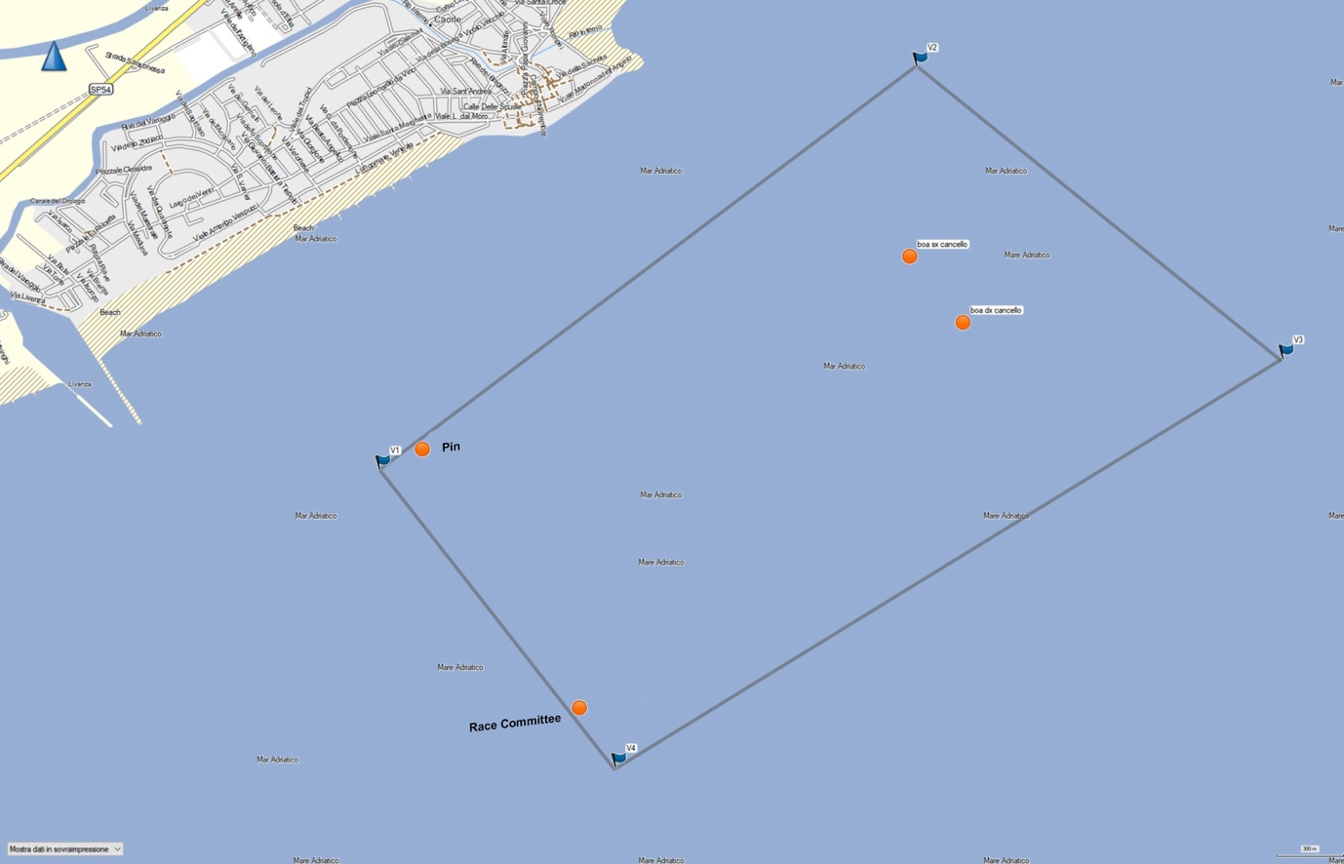
ATTACHMENT 2

